The Triad/Triune Concepts that lead to the Fundamental Model

This material offers a transition from the concepts of Kartajaya to the elements of a fundamental model. First, Hermawan Kartajaya, author of several books, among them a book with many details and explanations in it that Kartajaya co-authored with Phillip Kotler – the worlds leading marker: Kotler, Philip, Hermawan Kartajaya, Hooi Den Huan, and Sandra Liu. Rethinking Marketing – Sustainable Marketing Enterprise in Asia. Singapore: Pearson Education (2003). Starting at p.48, then ff.

The Kartajaya Triple Triad of Relationships – The Triune Model

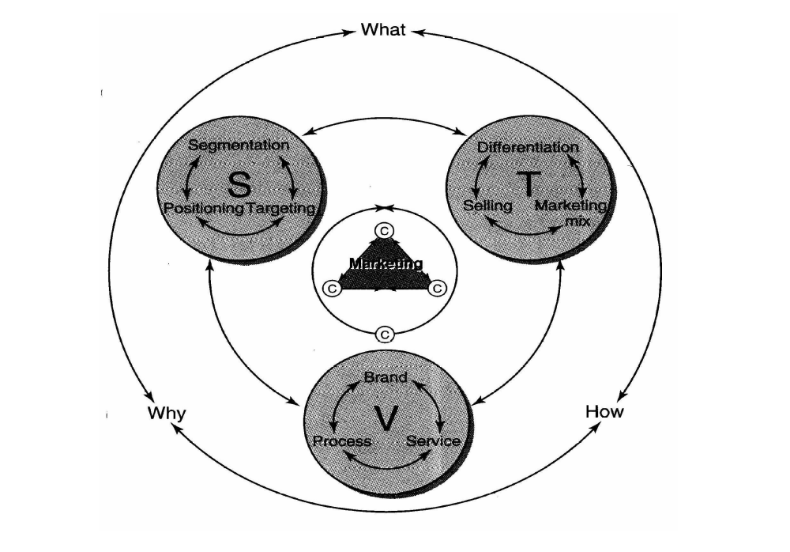

The first thing to note is the center. There ‘Marketing’ emerges from an intense interaction among ©’s - the company, (our) customers, and competitors (for our customers) mutually interact while enveloped in a symbolic circle of constant change. The next level shows the activities of the firm organized into Strategic, Tactical, and Value categories, which themselves are then surrounded by questions that decisions taken inside the circle must answer: What do we provide, why, and how?

Marketers frequently speak of positioning and differentiating a brand. Note that in this depiction of the firm’s marketing efforts that sentence simply equates to a strategic ‘focus,’ then followed by an implied tactical ‘capability,’ and finally leads to a value outcome – an incremental increase in brand equity. Throughout the look at this model the special relationship of positioning, differentiation, and brand enhancement in the STV triad should be mulled over – in many ways this particular selection from the nine elements is most critical. Generically, this implies that building focus yields strategy that is then operationalized by building ‘action capability’ in order to build and enhance the market franchise/value of the firm. These three efforts typically become the boundaries of your business, so they are intrinsically critically important.

From another viewpoint, the basic reason for Strategic activities collectively is to win ‘mind share’ in the ‘perceptual stores’ of the collective consumer brain. This is accomplished first through the mapping strategy of the firm – charting the mosaic of identified segments comprised of segment members having similar characteristics and behaviors, but with the segments themselves differing enough from each other to establish their unique identities, e.g. – scholarly youth, sophisticates, sportsmen, etc. Strategic decisions then follow to target (select) one or more segments to serve after the determination they are a fit to the offerings to be made. Finally, positioning takes place, the planting of perceptions, to firmly establish the offerings in the minds of the chosen customers.

The Tactical activities are dedicated to winning ‘market share.’ The core tactic is differentiation, which is distancing, distinguishing, and otherwise perceptually separating your offering from other contenders. Next, the marketing mix – the 4P’s – tackles the offering (product, price) itself and all associated logistical (place) and communications (promotion) issues. This is creation tactic to integrate and coordinate the critical decisions; note again that the marketing mix is identified here as tactical – this implies a shorter time frame, more flexibility, activity beginnings and endings, and more of a campaign orientation and less of a total firm focus orientation. It is not a fact that these marketing mix elements, e.g., price, could never be strategic (Wal-Mart); another marketing mix example at a strategic level could be product type, like a flame-broiled burger (Burger Chef). Any decision to become a franchisee buys into a strategic place concept (distribution and logistics) that lies at the core of the franchise business model (McDonalds). However, for many businesses the mix elements are much more malleable, less long term, and operate as tools to achieve strategies.

Finally in the tactical arena we have the capture tactic that generates the firm’s revenues – selling. Selling is also a foot-in-the-door, nose-under-the-tent activity (at a tactical level) that can be developed into a relationship (at the strategic level), assuming other tactical elements are properly configured and coordinated for the specific customer at issue.

Beyond mindshare (strategic) and market share (tactical), the firm must always address customer relationships, which is where we seek ‘heart share.’ In this Value portion of the triune model, we first consider the value indicator – Brand; this enables the firm to avoid the commodity trap – being seen as just like others. The Brand-Customer relationship is then value-enhanced through Service. In this context, Service means solving problems by being a firm that becomes a paradigm in the customers’ minds for a ‘near-associate’ who creates lasting value for customer through the product and service mix overall. All businesses must be in the Service Business (Peter Drucker says this is always the answer to the question: What business are you in?).

Finally, Process rounds out this trio as value-enabler. A necessity to earn the heart of the customer drives the successful firm to become an aggressive ‘Master and Commander’ – of the supply chain, of networked (partnering) organizations allied with the firm, and of the tools for improvement – benchmarking, re-engineering, outsourcing, mergers and acquisitions (as a few examples).

Formulaically, value enhancement can be expressed several ways. Two of the clearest are:

Benefits (total ‘get)
Value = ---------- … or more specifically,
Price (total ‘give’)

F_{b} + E_{b}
Value = --------- … where,
P + O_{e}

F_{b} = Functional benefits (utility)
E_{b} = Emotional benefits (psychology)
P = Price (charged) for acquisition
O_{e} = Other expenses/costs of acquisition

Within the heart share construct, the profitability of a strong brand driven by customer-perceived value is plain. With Brand at the core of value, in many ways the firm is liberated from the supply-demand curve; this permits price making (setting the price point) instead of price taking (echoing the market). ‘Getting to Value’ is clearly interactive with the other elements of the triune model.

This conception of the relationship of the elements of marketing was called ‘bold and audacious’ by Phillip Kotler, perhaps the best known marketer on the planet, just before he co-opted Kartajaya by aggressively becoming his co-author. In simplest terms, Dr. Kotler could not let someone with these insights and with a strong Asian foundation (in a globalizing economy) ‘get away.’ He didn’t.

