The Firm as Actor: What Makes It Go?

The firm RUNS on Knowledge; it is its fuel. The firm, using due diligence that generate such Knowledge and OODA (about which more later) that exploits it, applies itself to the challenge of creating a sustainable competitive advantage serving its customer base – a legitimate customer base, with things they do want - over time. Parallels among and between due diligence, business research, marketing research, creating a solid business plan, and market and marketplace analysis are pronounced, and profitably exploitable. First let the student not exhaust but merely sample the many ways to ‘look at’ a firm, and there are many.

The more static of the theories of the firm competing with the Knowledge-Based Theory (KBT) variant concern: Property Rights, Principal/Agent (Agency), Transaction Cost Economics, Measurement Cost, several variants of Contract Theories, and Information Economics.

The strategic, dynamic theories competing with KBT, a dynamic theory itself, primarily are: Resource-Based, Dynamic Capabilities, and Core Competency/Competence-Based Competitive. The readers are left to explore these other variants for themselves – references available.

We choose for the student KBT, without apology. However, there are specific implications associated with the chosen KBT or Intelligence Model of the Firm ‘way.’

You will find as you go on, should you stick to doing business successfully as a focus, that the ‘shtick’ is a about an overwhelming convergence of everything you knew, can learn, and may in future learn about the short-, medium, and long-term relationship with a person who needs or wants something – knowingly or unknowingly; a person who may or may not be or become your customer. It comes as a surprise to many marketers that their most critical skill invariably is their ability to meld and integrate management, accounting, finance, research skills, psychology, and fairly simple math and stats to get to marketing, and spring from marketing to sales and distribution and allied service subjects. You can never know too much, only too little; knowing too little bleeds off resources without adequate return – the extension of that scenario is played out every day in this country and abroad – and is identified as ‘business failure’ in businesses of every size.

The major (and intimately related) causes of firm failure are directly attributable to principals within the firm (1) running out of money (poor planning, inaccurate budgeting, or inadequate demand, among others) resulting primarily from (2) simply not knowing what they are doing – most often with their customers, hence, with the whole business. Peter F. Drucker said over a decade ago (“The Theory of the Business,” Harvard Business Review, Sep-Oct, 1994, pp. 95-104): “It usually takes years of hard work, thinking, and experimenting to reach a clear, consistent, and valid theory of the business. Yet to be successful, every organization must work one out” (Emphasis added). He provided his four guidelines to a valid firm theory for consideration. I repeat them here: (Remember this formulation when you later cover materials about matrices in planning).

      - The assumptions about environment, mission, and core competencies must fit reality (later ‘FEF’)
      - The assumptions in all three areas must fit one another (later ‘FOS’)
      - The theory of the business must be known and understood throughout the firm (later ‘learning organization’)
      - The theory of the business has to be tested constantly (later ‘hypothetical-deductive information cycle’)

Now, how does one understand and plan marketing action? Simple - define the customer, the firm, and the operating setting – then plan, then act. The formal planning process, as depicted in detail in your texts in various ways, mandates your full understanding of what sort of a business model defines the firm, what interaction the customer enjoys (they better) in your particular business model, and the dynamics of the firm-customer environmental setting and, the payoff - achievable relationships with the customer, to what effect, and how, and for how long.

Firm ingredients necessarily brought to the firm-customer relationship include a firm’s vision, its mission, goals and objectives, and a business model that honors and values present and potential customers. The messy ingredients brought by the customer to your party vary from undefined, to ill-defined, to well-defined needs, wants, and usually a vague awareness that all is not right with their world. Everything else – Everything Else – is the setting - hence, the necessity for enthusiastic due diligence. You essentially exist as a business (and continue to exist) solely to provide for customers more life satisfaction (at work, traveling, or at home) and less stress. You are only nominally a manufacturer or a distributor or a retailer – functionally you are a problem solver for life’s small, medium and large problems. If you can solve their lives’ problems, you may succeed; if not, by default you then become a part of the customers’ and the market’s historical memories. This may sound Darwinian – it is. If you are not providing what the customers want, you cease to exist.

Below we will ‘chunk out’ ideas from the dozens of interrelated ideas comprising essential concepts that make up the practice of the most fascinating activity on earth. Business models and concepts are from every discipline, and an area in which many such borrowed ideas converge is in marketing.

- Intelligence (Knowledge) Model of the Firm

In this version of a model of the firm the central importance of data, information, intelligence, and knowledge cluster is featured. There are three assumptions underlying this model: (1) There is an information hierarchy (originally DIKW, now DIIKW) in market thinking that has been a useful framework over time (T.S. Eliot, poem The Rock, 1934; Harlan Cleveland, “Information as Resource", The Futurist, December 1982, p. 34-39; Milan Zeleny, Zeleny, M. "Management Support Systems: Towards Integrated Knowledge Management," Human Systems Management, 7, 1987, pp. 59-70.) (2) The Communication-Information Theory Model (Claude E. Shannon, 1948; Claude Shannon & Warren Weaver, 1949) is intrinsic to the processes served by DIKW, and (3) there are obvious parallels to the Theory of the Learning Organization (Peter M. Senge, The Fifth Discipline, 1990) - all representing ideas well worth exploring and understanding.

The customer as student is unavoidable in a ‘new age,’ as was highlighted by Davis and Botkin (1994) in their Harvard Business Review article “The Coming of Knowledge-Based Business.” A key issue becomes providing customer answers to product and knowledge questions, realized or latent, spoken or unspoken. An argument – both firms and customers learn and teach.

There are many representations that show The Firm in its information sink and source role, and which also try to show what is happens internally. (Now please view the Power Point Associated with this Module). Here we simply show a large number of related information flows and processes. Undergirding what the firm says (communications), does (sales and distribution) and how it conceives and integrates the markets for its products (marketing) are internal activities that comprise the planning function, management, analytical capabilities, analyses of the environmental issues, macro and micro looks at the economy, a thorough evaluation and an action plan for funding the firm, much of which drives the firm’s ‘make or buy’ decisions.

The model shows the information gathering from primary and secondary sources. Primary sources are most frequently those investigations intended to capture information directly from the customer (market) and facilitator (distributor) base in relevant markets and supply/value chains. The firm is attempting to discover the rules to live by. Often this involves marketing research using well-tested data gathering instruments to create target databases, followed by data evaluation, strongly inferred findings, applications to real customers, and repeating the intelligence cycle. As Peter Drucker has noted, it must never end. Both marketing research and analysis of customer response will suggest further ‘hypotheses’ the firm must continue to explore, which must include carefully observing all discernable results achieved by their competitors. These findings guide behavior in markets until there is reason to change. Secondary sources are those reports, sources, and databases that reveal in whole or in part aspects of what you need to know to better find and serve your actual or potential customers; this information and intelligence is most frequently work done by others for others, but often such information can be found already resident in the firm. The problem with this data is relevance and timeliness – it too often has ‘aged out’ and also must be evaluated very critically for current relevance to the research questions of the firm.

All of the data, information, intelligence, knowledge, wisdom, and philosophy that can be acquired by whatever means becomes the base for learning, teaching, and self-study within the firm such that the appropriate offering is made to the appropriate customer base, using QFD to assure customer-offering fit. Once there is internal confidence that the decisions are good and the offering is viable, then the carefully garnered knowledge of the market and the offerings that have resulted are shouted from the rooftops – the entire communications mix of the firm is engaged to inform and persuade the targeted markets that it is time to engage. It is easily seen that this is not just advertising, as the Davis and Botkin article cited above suggests.

In addition, Phillip Kotler and Hermawan Kartajaya in collaboration provide a memorable image of the ‘nuclear role’ of knowledge in the business process. Their conception claims that the value of a firm is directly related to Knowledge-enabled
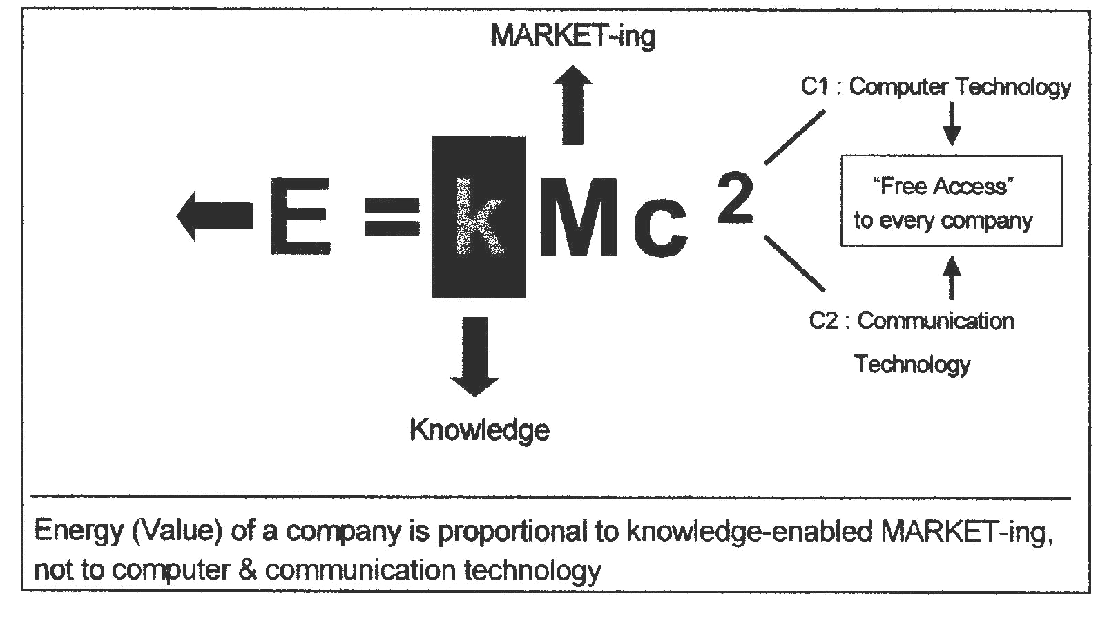
market-ing because the Computer and Communication technologies (so often credited with great business outcomes) are reasonably available to many firms around the globe today. Therefore, Value derives from the leveraging of these capabilities.

Their obviously ‘borrowed’ E=MC² framework conveys what Kotler and Kartajaya intended - sheer power. Sheer power is generated by ‘adequate relevant knowledge’ deployed using ‘appropriate customer-oriented process.’ It is a compelling formulaic image. Materials are provided elsewhere to articulate these ideas in more depth, but the formula highlights that knowledge is at the core of this ‘firm/business model’ – one provided by the world’s leading academic marketer and arguably the world’s leading ‘emerging markets’ consulting practitioner-marketer.

