Part I: Due Diligence: Going to Gemba

Getting to a point where you know what you must about your customers is difficult. One could guess, speculate, discuss, or take any number of approaches; one could ask customers questions, evaluate problem situations, train customers on product use to become familiar with their approach to our offering, or any of a score of methods of determining what is happening with our product and the customer. The key is “Have we delivered the value we promised?”

An alternative to just asking is observing and engaging in dialogue. One can physically (hence psychologically) go to the place where the product or service acquires it value to the customer. You experience the product interaction with the customer. This takes a lot of time. It is not at all surprising that this technique of taking the time to really know the customer emerged in a Japanese context. The Japanese people are known for their patience and thoroughness. Sony executives claim to have in mind a 500-Year view of their firm. Clearly time is viewed differently across our two cultures.

The patient, observational method of being with the customer ‘as long as it takes’ is called Going to Gemba.

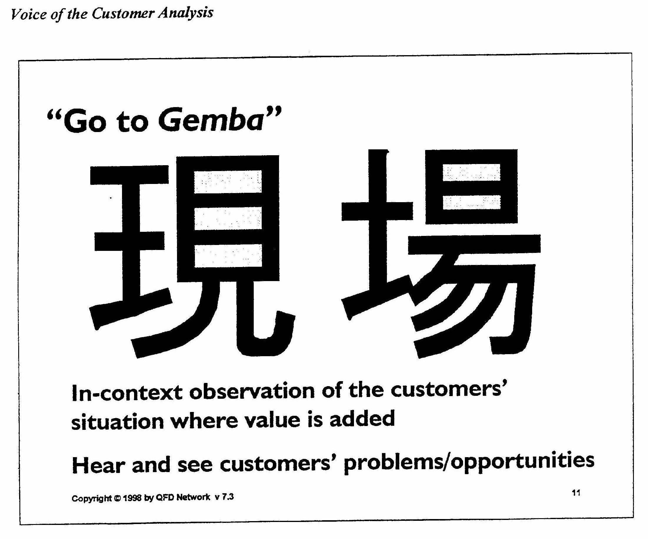

“The Japanese have coined a word to describe the true source of information about value creation – the gemba. Gemba can mean the place where the work is done, and has been used in Japanese publications in this manner. Gemba also can mean in a business sense, going to where the product actually gets used. It is when we go to Gemba that we see our customers as they interface with our products and seek the value additive we have told them is there. As they interact with the product, we see what their problems are, how the product will be used by them, etc.

We also go to Gemba in QFD to see our customer’s problems and opportunities as they happen. … (We do not use traditional research and customer memory) rather, we can employ all of our senses to work for us by using contextual inquiry, video taping, audio taping, direct observation, direct interviewing with customer’s employees, etc. for the larger purpose of trying to understand how we can help our customers better conduct their business with their customers.” (Glenn Mazur and Richard Zultner, Voice of the Customer, QFD Network, 1998, p. 11.) We can capture customer behavior and language as they work with our products and any other products they use in the same or similar tasks.

The actual breakdown of the kanji for the place where value is added:

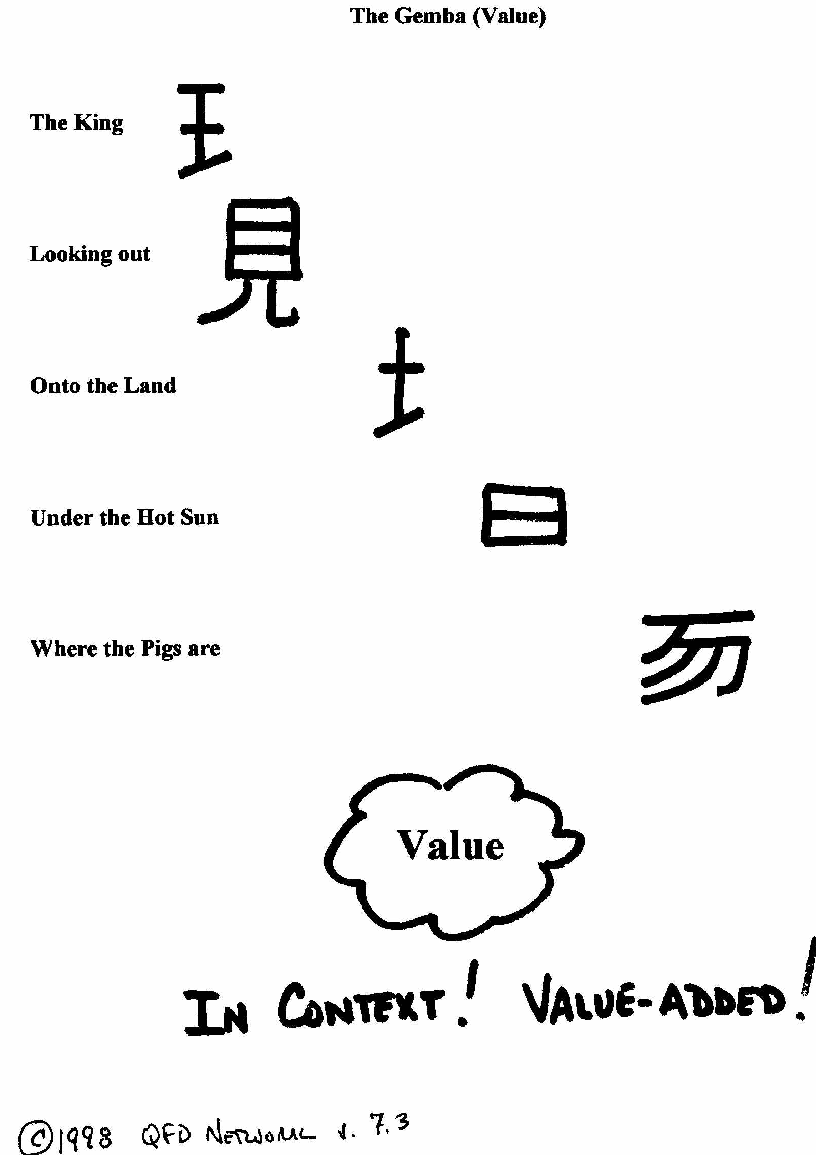

One sees that the original phrase picture (Kanji) is from an agricultural era. The sun is shining, the land is producing, the wealth is being created – the king can see this, observe it – he is there. Gemba is a powerful concept of where to be to understand your valued customer’s wealth creation process using your offerings – there!

Another interesting thought from Glenn Mazur: Nothing Wrong ≠ Anything Right

In a highly competitive setting – most are – the firm must focus on spoken and unspoken needs, and doable exciting delights. And to get nothing wrong is not good enough any more. A golden standard in serving your customers is now getting everything more than just right, maybe even all the way on the satisfaction spectrum to delight.

An idea related to the above addresses metrics that describe ‘what is wrong.’ Many traditional measures of (especially) manufacturing processes often key on tolerances: Lower /Spec Limit and Higher Spec/Limit. As long as what we are doing falls ‘within limits’ we are doing nothing wrong. There is a higher standard. [I know! You know about Genichi Taguchi already!]

Now, in your projects you must demonstrate a keen knowledge of the customers you propose to serve. You must develop this level of familiarity using whatever tools you can deploy. Perhaps you choose to visit B2B customers, or question B2C customers who are ‘real people.’ We ask only that you discuss this with us ahead of time. It would be a useful way to ‘know the customer’ but you should be aware that there are many rules involved in such ‘research.’

Part II: Due Diligence: Inclusive Framework for Strategic and Tactical Thinking

Scholars and practitioners have devoted significant attention to what specifically we should study in order to ‘do’ adequate (it is difficult to get beyond adequate, and unfortunately it’s always initial) planning. One such scholar-practitioner is Dr. Peter Dickson, a New Zealander now at Florida International University (last known). Full disclosure requires confessing that Peter was my major professor and primary mentor for five years; his basic strategy matrix has been the core concept for much work in the field. I have embellished it over the years:

Customer Competitor Channels Compliance Company

Product

Price

Promotion

Place

Here we have the McCarthy 4P’s (a ‘marketing classic’ framework) that has long been treated as a strategic marketing planning framework. Product, Price, Promotion, and Place are best addressed as tactical, so we will deal with that modified idea (in class and with Kartajaya below).

Environmental Constraints on Market(ing) Behavior

Intended behaviors/actions (strategy and tactics) in the marketplace have to FIT the circumstances they encounter, usually called the environment (and addressing that issue is called environmental analysis). Circumstances in the environment are represented above: Customers, Competitors, Channels, Compliance/Legal/Regulatory, & Company.

To those we add pervasive topics that pertain to and must be considered in each cell analyzed: Ethics, the overall Economy, and advances in available Technology.

Other marketing authors such as Lehmann and Winer do not ‘see’ the 5-C’s when they characterize the environment; they see Technological, Political, Economic, Regulatory, and Social environments. You must decide if these are more suitable characterizations of the elements of the environment.

Your text authors DeThomas and Lin see as external - Industry-market-competition, Economy, Technology, Social-legal-political, Demographic; internal - (and presumably controllable elements) production, cash flows, etc. Everyone has an opinion. Again, you are responsible for the product, so you must decide.

Key: What works analytically to characterize the environment so that you can determine whether your offering FITS?

The critical aspect of this section is that all of the intersecting cells in the 4P-5C Matrix above must be filled in with relevant information suited to decision making. ‘Facts’ defining these intersection cells must both define the dynamic being examined (e.g., product-customer) but also be consistent in any internal examination across categories (e.g., whether promotions will be primarily billboards and magazines due a lack of other media/communications channels; if so, the inclusion of extensive television regulations on advertising may be wasteful of time and space in your analysis. If there are extensive sophisticated electronic channels of information delivery, the extensive regulations in this arena, your and the Competitors’ behaviors with regard to, say, comparative TV advertising, clearly they should be included as legal aspects in the Compliance area for reference and analysis.

So there should always be consistency, coherence, completeness and credibility at the intersections, and among the 4P’s and among the 5C’s. The check acronyms for this are FEF (fits environmental facts) and FOST (fits other strategy and tactics).

A good question always is: Does that make sense? I am a proponent of the viewpoint that if it does not make sense any more, you have eased out of marketing thinking into some other discipline (we tend to do that, as marketing does overlap significantly).

One discussion is about the numbers of categories on the axes and the specificity of planning: If you have Pricing tactics, why not an overall Profit strategy? Why not divide Place into Distribution and Logistics? These are embellishments I use. You use them if they are useful. This tool must work for YOU.

I believe we have done, and will dwell, upon information and thinking again and again. The answers to these and a host of other logical questions will be your answers, and you will arrive at them after getting information for your needs and engaging in your thinking about them. There are templates, and there are completed plans – that FIT. You are responsible for the imagined success of your product as ‘pitched.’ You aim to get it all and get it right. There is a lot of information to be moved in looking for the nuggets.

To learn all that one can contributes to future success, at unexpected times and in unexpected ways.

A future topic (Module 13 – OODA Loop) is about (competitive market) decision making (and any other decision), and includes a component called Orientation. Two areas within Orientation are New Information and Previous Experience. To make ‘well-oriented’ marketing decisions, the starting point is a good ‘fill’ in the cells of the Matrix, the inclusion of necessary information (boiled down to intelligence) and cast such that problems are dealt with and each cell is a good ‘FIT’ as noted above.

Part III: Due Diligence: Digging for gold (while some folks find it scattered about)!

In this vein, and to state the obvious, there is thoughtful reflection associated with going into in business; in fact, thinking is the core process. We would hope that the entire landscape of success is populated by those who have outthought and outperformed the slower, weaker, and less insightful. But in looking at businesses across the board, there is clearly an element of doing well and profitably what many others choose not to do, or just ‘get there’ too late to get in on the act - not being the one lucky enough to be the first provider where only one provider makes sense.

Bluntly, some business avenues are already closed and have been for some time – the ‘first movers’ or their successors are doing those tasks and meeting those needs in society.

The characterizations that follow are not inevitable for any business. Note that some apparently thoughtless businesses may mimic in profitability and sustainability those that are diligently thoughtful. Some environments and scenarios seem to engender business success through happenstance and serendipity without much thought. One can become rich as a scrap metal dealer of very modest education. Or one can capture poverty as an innovative genius with vision who, unfortunately, tries to serve a small customer base with near-zero product demand, with a dearth of resources, all of which operate within a seriously flawed (if modestly innovative) business model. If that business had been ‘run through’ the strategic matrix, perhaps green cells would be rare and red cells plentiful. But I am bloviating.

It is useful for the sake of argument to consider a mini-hierarchy of business configurations: the minimally thoughtful, those which are moderately thoughtful, and also those which are supremely thoughtful.

      - Basic: Constant demand, oligopolistic businesses tend to be minimally thoughtful, with effort devoted to access and cost control (e.g., heating fuels, electricity, water, or garbage). These slots are usually ‘all taken’ because of their universal and basic demand and finite markets in an area. They are typically very profitable.

      - Commodity-like: Moderately thoughtful businesses tend to have fairly constant demand, but competitive settings, and devote effort to price and transaction quality (e.g., food, clothing, scrap metal). There are many folks here, and much ‘churn.’ But those who provide the basics for living, and do it well, themselves often do well.

      - Challenging: Supremely thoughtful businesses have discretionary demand, a competitive setting, and devote intense effort to offering quality and customer relationships (e.g., PDA, or laptop computers, or cell phone services). The more competitive and the more numerous the suppliers, the smarter the entrepreneur or businessperson must be. Often these businesses rise or fall on the value proposition, much more so than others; and the incremental improved benefit may create substantial churn in the market. But again, ‘well done’ is ‘well off.’

The challenging venue invariably requires better executed offering design, a solid and definable differential advantage, and outstanding communication from the firm and to the firm. We prefer it. Clearly, the setting and offering – the very nature of the business - can greatly influence the demand function and the effort required to succeed. While every business deserves and demands noteworthy expenditures of Due Diligence, some businesses are so straightforward and perhaps so easy that even a caveman can run them (a phrase rapidly headed for political incorrectness).

As for your business, assume effort; focus upon business concepts in which we can see and evaluate the thoughtful work involved. Dig for gold. The more toward a commodity one tends, the more difficult it is to benefit from the project. However, there is a caveat; recall that your project has to have a substantial ‘Information Highway’ component. If this can be done related to a commodity, more power to you. Create that value-added element. DO MARKETING; honor the Fundamental Model. You go…

Guideline: In 622 we not only encourage taking the thoughtful approach, but also believe in the well-done plan, and in a credible, thorough explanation of execution. We do want to see that DD element...

Recall JFK: “We choose to do it not because it is easy, but because it is hard…”

This cautionary note is also germane: Keep an open mind. Some projects have been defended to the death by (often the originating) group members. Then, at the midpoint or later, it becomes obvious that it is just NOT going to work If we were to cast aspersions, we would say they failed at appropriate DD early on! But this hard-headed stickiness to the ideas we conceive is a common phenomenon, even ‘out in the world.’ Business people become very excited about their own ideas, and that tends to get in the way of this recommended thoughtful analytical process. As an example, one of the biggest problems we have with ‘real’ product managers is the ‘but it’s my baby problem.’ They cannot admit to themselves that their product has failed, tanked, crumped, nose-dived, self-destructed, and other such vividly descriptive verbs. They argue vehemently for ‘just one more quarter’ as the product is ‘just about to take off’ – maybe so, but infrequently. Thinking, and doing so early on, helps here!

Another cautionary note as projects go forward: An observation - the most dangerous words in business may well be: ‘Everybody will want one.’ Will they? First, why do you think so? Second … want one; why just one? For those who do, how much will they pay, and how much does it cost you? DD always rears its useful head.

The news: Everybody does not ‘want one,’ and some who do ‘want one,’ you cannot afford to serve; and you should reflect that in your ‘business model.’

