Quality Functional Deployment – At the Heart of Customer Satisfaction

Customer acceptance (within a targeted segment) of any product offering as the best for their needs lies at the heart of the firm’s success in building a repurchase, brand loyal relationship with the customer. To achieve such a goal the perceived need of the customer must be known; then full satisfaction of the perceived need(s) must be executed well. Simplifying this issue, consider the lowly wooden pencil.

Customers for wooden pencils can be segmented into named groups, e.g., a carpenter, a K-to-first grader, and a high school student are each probably in different customer segments for a ‘most preferred’ pencil. You are familiar with the carpenter’s pencil – flat, softer lead, no eraser, and sharpened by pocket knife. Early graders do not articulate their needs in marketing speak, but they are well known to teachers – big (for unpracticed little hands), round, big soft lead, and it is easily sharpened in the wall pencil sharpener. A high school student buys a ‘normal’ size, hexagonal, often yellow, frequently #2 pencil, with an eraser on one end. Such choices reflect different strokes for different folks.

If a marketer were to evaluate the competitive market for wooden pencils in one such category, say ‘normal’ student pencils, the marketer likely would ask questions or observe (i.e., research) and also seek information (secondary data) that may be available. In such a firm, many historical sources, databases, and product experts could provide a lot of information. One would need the preference for wooded over mechanical instruments, and especially the preferred characteristics of the pencil itself. Perhaps the marketer, after careful survey research, not just with students but with the larger buying public for such a ‘standard’ pencil, determines that the customers wanted a pencil that was easy to hold, made an easily legible mark, did not smear, had a good point that lasted, did not roll away from them easily and erased readily, among other requirements. OK, what does that mean?

When the marketer sits down with the design engineer, the production staff, and the packaging and distribution people, what does “had a good point that lasted” mean? It is at this point that quality functional deployment (QFD) becomes exceptionally relevant as a concept if not a formal process. The function performed in the approach we now discuss must happen, one way or the other, less or more expensively than the formatted and somewhat formalized method we discuss here. Having stated all of that, this is just a tool, but a powerful tool.

It is not too much to note that engineers do not speak very much ‘marketing’ and marketers speak even less ‘design engineering.’ However, the need to communicate is paramount. One method (to be discussed later) is for engineering, distribution, and marketing people to ‘Go to Gemba’ together and compare notes over time. For now, however, the method we discuss is QFD – linking perceived need to perceived benefit to technical specification, and using the QFD matrix to correlate all observers’ data and information. QFD methodology transcribes the voices of the marketer, the engineering designer, and customer perceptions ‘onto the same page.’ Historically, this method has been called ‘The House of Quality’ because quality emerges from the process – a level of quality often unachievable by other means.

The example offered below addresses our lowly pencil. It assumes that marketing research has been conducted yielding ‘Product Requirements’ (e.g., Does not roll) and ‘Design Requirements’ have been established to address those requirements (e.g., Incline angle to roll). The marketer will likely discover for differing product categories that the depth and variety of corporate experience and available information in those categories is extremely extensive (e.g., automobiles, foods, clothing, and even wooden pencils).

Though QFD looks complex, it is not. It reduces disparate disciplines to a common language, and provides ways to determine what is important, less important, and unimportant. It also provides a vehicle in which marketers and engineers (and many others) can travel to desired customer goals. It also enables competitive comparisons in useful ways. It drives the design team to ‘commit quality’ in the name of the customer.

In the wooden pencil QFD matrix below, the left middle wording (Product Requirements) is from marketing, the left lower wording identifies objective engineering data, the top middle wording reflects selected engineering metrics, and the top right wording and ‘Total and %’ on the left show their joint evaluations. (There is an implicit scale where used of 1 = lowest and 5 = highest).

Note that the importance of the product requirements was rated by customers and recorded in the ‘Importance rating’ column. Sharpencil (now) and Competitor X are rated in the adjacent columns; then the Sharpencil (target) is assigned a value equal to the highest of those ratings. Then the target design improvement compared to Sharpencil (now) is calculated (e.g., ‘Point lasts’ is targeted at 5 and our ‘now’ product is 4, so the ‘Rate of improvement’ is 1.25). The distribution and sales sources have added a weighting that reflects how important the product requirement is to making a sale (Sales point). Then the joint product of Importance, Rate, and Sale generates a Row Score (e.g., ‘Does not smear’ is 4 x 1.00 x 1.2 = 4.8, and ‘Point lasts’ is 5 x 1.25 x 1.5 ≈ 9.4). Finally, the Row scores, which total 25.3, are standardized to total 100 (multiplier ≈ 3.95267).

Back in the heart of the matrix are symbols (∆, O, and ‘circle •’) representing the intensity of the relationship between what a marketer and customer describe as a requirement, and the technical metrics established by design engineers to operationalize ‘soft’ marketing descriptions. The values used for the symbols are consensus values, and could vary. Here, for computational purposes, these symbols become the product of their own value (1, 3, or 9) multiplied by the Normalized Score recorded at far right in the row. Then the newly created ‘symbol values’ are added downward into the Total row (e.g., the ‘Lead dust generated’ Total is 9 x 19 added to 3 x 37 totals 282). Then these normalized (unit-less) totals can again be factored to a base of 100, yielding a percentage of importance for the design engineers’ specification. Note the engineers also evaluated the existing products and (for the most part) assigned ‘best’ target values to the new Sharpencil – e.g., a long ‘Time between sharpenings’ and low ‘Eraser dust generated.’ Now marketers and engineers can talk about ‘Does not smear’ in terms of the perceived customer importance, the selling power of the attribute, the strong relationship of smearing to ‘Pages per pencil’ and ‘Lead dust generated’ and the weaker relationship to ‘Time between sharpenings’ and the even weaker association with eraser strokes.

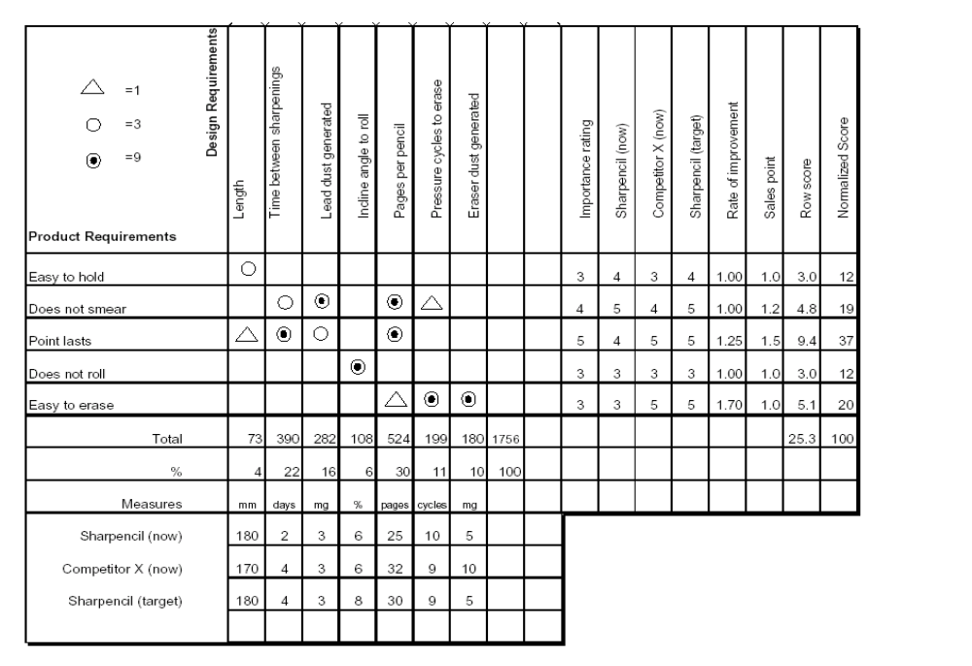
As trivial as the example may seem, QFD is a key method for instilling quality into a product that will then well satisfy the customers’ perceived requirements. Scores if not hundreds of such matrices are required in any ‘meeting of the minds’ on automotive design issues such as engine power, road noise, smoothness of ride, fuel economy, comfort, information displays, sound systems, luggage space, and so on. As an exercise, we can discuss ‘car door’ (class).

The extraordinarily high utility of the QFD construct in doing ‘good marketing’ makes it one of our core models. But, like the others, it is nothing more or less than a tool to facilitate organized and thoughtful due diligence. It has escaped no ones attention that QFD lies right at the heart of the ‘delivered benefits’ component in the Person x Situation segmentation construct.

