Featuring the Decision Windows in the PLC

Product Life Cycle, Entrepreneurship, and Diffusion of Innovation relationships

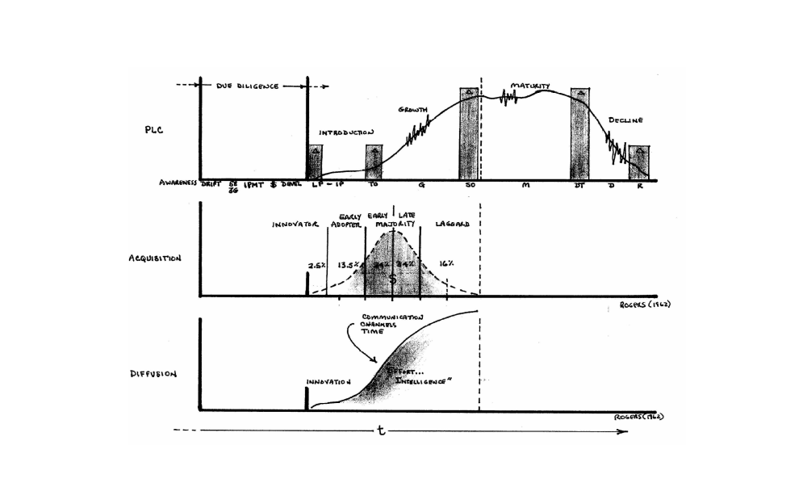
While every business is challenged to survive and grow in the long term, it is also necessary to be around in the short term. Survival of the firm and its focus and its vision beyond an introductory stage is obviously mandatory. While it is true that all big firms were once small, they had to grow, not flounder, to be big. Above is depicted the product life cycle (with decision windows for upcoming phases).

The ‘window’ embellishments to the PLC are critical. First, the introduction or launch of a new offering does not just happen. The due diligence and planning actually determine the eventual success to a greater extent than other factors most of the times offerings are launched. The phases of due diligence are as important as the PLC concept itself. These include activities related directly to the deliverables you are responsible for in your projects regarding the industry and markets.

In the initial due diligence, there is often an awareness of drift in the existing offering-to-customer fit with current products in the market. There are inevitable tendencies to drift in business: mission drift, budget drift, segment drift, and here fit drift.

If marketers plan a new approach or try new applications for products that is shift, and is intentional. Drift is more insidious in that it is more gradual in many cases, though an innovative and effective competitor can take a market by storm and blow your firm away; but the signs of that happening are hard to miss (although many have).

This drift, when noticed, should drive marketers into a reanalysis of the 5 environments in which all firm offerings are embedded: customer bases, competitive sets, distribution and channels, system-imposed constraints (often legal), and the assets (human and other) of the company itself, and the firm’s documentation supporting the offering. As well, the ‘company-competitor-customer triangle’ (Kartajaya) and the Fundamental Model should both be diligently reexamined to first determine for these key elements what if any drift has resulted from the stresses of change encircling them.

Then the Fundamental Model is worked with thoroughly as an idea generator and road map to see what changes may be appropriate to re-center on the customer segment(s). Once a suitable plan is in place (Strategic Matrix for fit?) investments are budgeted, scheduled and made, and the development of the variant or replacement for your own or a competitive product (based upon new demands in the market) is then underway. When ready, then the introduction/launch is scheduled. Do not miss any ‘new rules of the game.’

Frequently drift occurs and the earliest more subtle signals are missed; but sometimes it is more of a seismic shift due to the aggressiveness of the ‘creative destruction’ of the market by the forces out there; a competitive onslaught, or a sort of dramatic change in customers or technology, information, or basic infrastructure.

With regard to signals or indicators, due diligence should have isolated key indicators in the target markets that will enable effective marketing management. On the PLC, the bands represent acknowledgement of critical inflections points (or windows) in the revenue (or units) curve that must be recognized so that critical decisions can be made.

Tactical and sometimes strategic decisions must be made in a timely way for the ‘next stage.’ As but one example, the type and content of advertising will change from the growth stage to the mature stage. Also, pricing (and profit) goals are often very different in different stages (e.g., premium pricing in introduction stage, penetration pricing in the growth stage – to buy share - and contribution margin pricing in the mature stage). Also, in moving from introductory to growth stages, the early indications of success are critical because of the nature and size of investments to be made to meet the growth stage demand satisfactorily. Stockouts are suicide in a competitive growth market.

The decision windows are the Launch or Introduction Point (IP), Take Off (TO), Shakeout (SO), Down Turn (DT), and in some cases the Resolution stage (R). The leading edge of these ‘windows’ are when timely decision making is necessary to keep the product on track. When the revenue (or unit) tracking per appropriate period (e.g., monthly, quarterly) reflects two successive 5% changes, that is usually a reliable signal of further impending inflection in the curve.
In the same due diligence vein, assessments of the market should reveal a strong sense of the sizes of the Rogerian adaptation groups – the marketer should have a good sense of when the innovators have topped out, and then in the growth stage, have a sense of what the market saturation level most likely would be.

Surprises for marketing, project, and product managers are usually their fault – too little front end professionalism, too little due diligence and too little thought!

For a more comprehensive discussion of the actual decisions that must be taken in a PLC phase, see the discussion in Word Document PLC Issues Discussed, which you may already have read.

