What Broadband Hold-Up Source: cablefax@aol.com

Source:
While US broadband adoption is trailing several countries, its 20% penetration shows that it has “completed the early-adopter stage and is at the threshold of mass-market adoption,” says the findings of a Price Waterhouse Coopers report called “The Broadband Future.”
The group projects that the number of high-speed Internet subs will reach 62 million by 2007. Currently, 26 million homes have access to high-speed Internet, the report says.
While broadband and dial-up users favor the same applications online (email, search, shopping and instant messaging), broadband Internet customers spend 50% more time and 64% more money shopping online. “Broadband consumers are four times as likely as dial-up consumers to download videos, are three times as likely to download music or watch streaming video and are more than twice as likely to listen to streaming audio,” the report says.
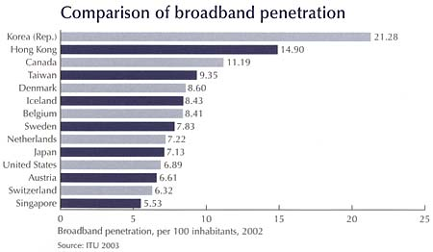

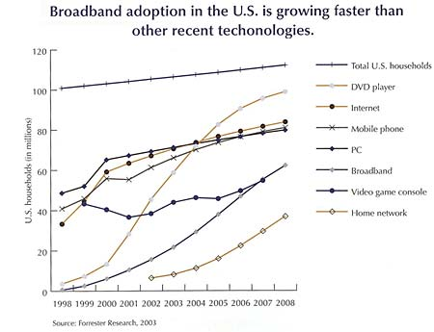

Source: cablefax@aol.com.

