The J. D. Williams Library has provided a campus-wide site license to the premier database and research tool for corporate financial information – Research Insights on the Web (RIWeb). This is also known as Compustat. This outstanding tool is useful not only for finance, accounting, and economics research and classes, but also for anyone who invests in stocks or who wants quick and easy access to company information, industry/sector averages, market indexes, and other economic indicators. The database includes 20 years of data on U.S. and global companies, including those that are currently inactive. Data includes all financial statement items, stock prices, volume, dividends, earnings, etc., as well as a comprehensive database on executive compensation. The database is kept current to the most recent quarter. With our new wireless network now up and running, RIWeb is an excellent resource with which students can research companies or industries from anywhere on the UM network.
RIWeb is a Microsoft Excel add-in, which means it installs as a component of Excel and is used like other spreadsheet functions, plus it installs its own user interface inside Excel so that those who are not Excel gurus can still make full use of it. This seamless integration with Excel makes working with the data very easy. Once you have installed the Excel add-in, you need to be connected to the data site. Access to the data site requires that you be connected to the UM campus network (which includes Tupelo, DeSoto, dorms, and (I think) fraternities and sororities) or that you access it through the J.D. Williams Library (a valid UM ID is required).
To install the RIWeb add-in on a computer on the UM Network, follow the instructions at http://intranet.bus.olemiss.edu/faq/riweb.
To install the add-in on an off-campus computer, go to the library's database listing page, click on "R" in the alphabet listing, and then click on "Research Insight on the Web (RIWeb). On the next page, follow the instructions under "RIWeb Excel Addin".

After running the installation program, open Excel. You should see a new menu item on the top menu -- RIWeb. You should also see a new toolbar for the RIWeb functions.

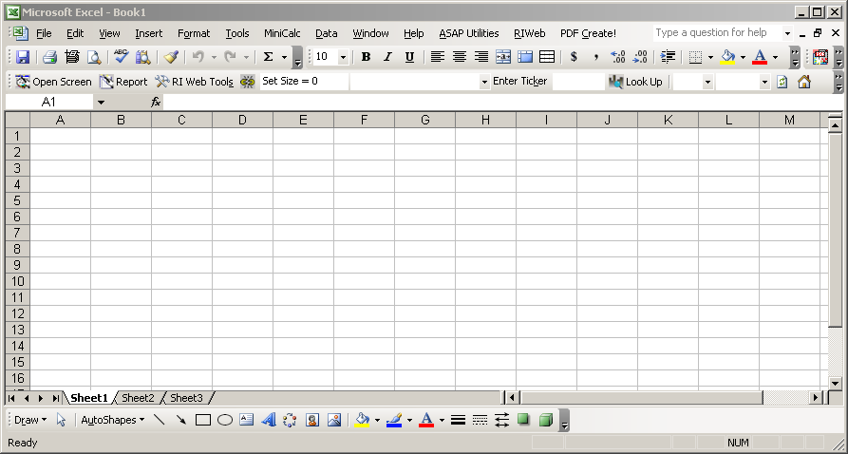

Click on RIWeb on the menu, and then on Research Insight on the Web Help, and then on Data Definitions, User’s Guide and Functions. This will take you to the web-based user’s manual, where you can get an overview of how the system works. A good place to start is the Navigating section, which provides an overview of the most frequently used features. Check out all of the features as you read through this section. Most of them are intuitive and very easy to use.

The Research Assistant is a great way to get started. Click on the RIWeb menu item and then on Research Assistant to access this tool. Note that the first time you try to access this after installing the program, it will ask for a username and password. Just leave them blank and click on NEXT until it starts downloading the database. That will take a few minutes the first time, but will be much quicker on subsequent uses. After it finishes downloading the data, you should see this screen:

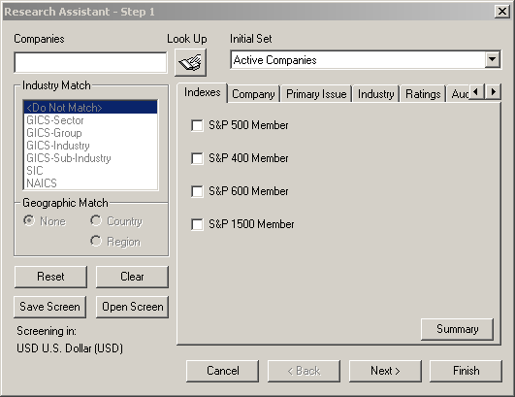

To get an idea of the information you can get, enter the tickers for GM (GM) and Ford (F) in the Companies box at the top left, separated with a comma (gm,f), and then click on Next at the bottom right. You can also do a lookup on the company name if you don’t know the ticker or screen for a list of companies using a wide variety of screening criteria, but let’s work with GM and Ford for now.

After clicking Next on the first dialog box you will see a second dialog box that allows you to add issues that weren’t in your first screening or remove some issues that you don’t need. We are happy with GM and Ford, so just click Next to move on.

The next dialog box let’s you pick the report you want to see, and there are lots of them. In addition to standard financial statements, there are many other reports that provide a wide variety of analyses on the statements. For example, double-click on Balance Sheets to open the extended list, and then double-click on Balance Sheet Analysis. Depending on whether you listed GM or Ford first, you will see the analysis sheet that company. Some useful charts or provided below the numbers. Check out those Accounts Receivable!

To switch the view to the other company, use the drop-down menu on the RIWeb toolbar to select the other company.

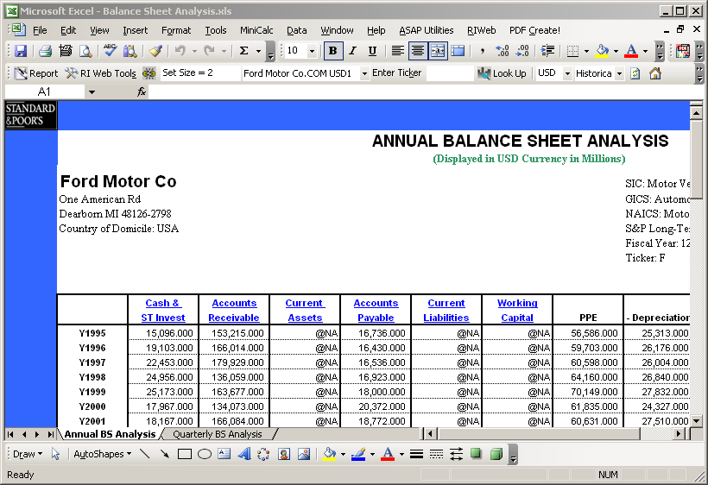

Click on any cell that has data in it, and look at the formula that is in that cell. Although it might look a bit intimidating, you can use a similar formula in any spreadsheet to directly access the most current data from this system and thus create reports for a variety of purposes that are always up to date. Since the data is live in the spreadsheet, you can also perform any other computation on it just like you would with cells in any other spreadsheet.

To look at another report from this set of companies, click on Report on the RIWeb toolbar to open the report selection dialog box.

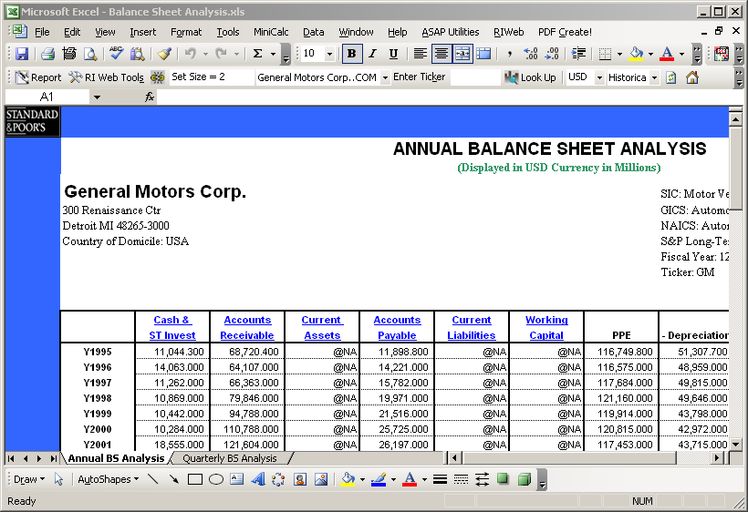

In the Report dialog box, double-click on Company Comparison, and then double-click on Detailed Fundamental and Value Comparison. The resulting screen will look like this:

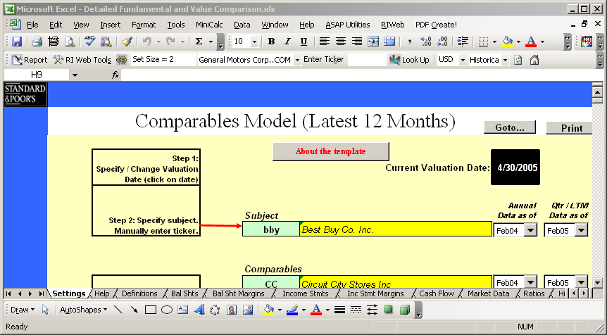

In the Subject entry box, type GM over the bby that is already there. In the first Comparables entry box, type F over the CC that is already there. You can delete the entries from the other boxes or leave them, or enter some other tickers you want to compare as well. After each change, the system will download the data. When you are finished making changes, click on the tabs at the bottom of the page to see many detailed comparison reports. Impressive, eh? (By the way, they all say GM and Ford are in sh^# soup.)

Driving such thriving companies must be hard work, so let’s check out the executive compensation. Open the Report dialog box again, and double-click on Company Overview and then on Executive Compensation. Yup, it must be really hard work. Those poor guys…

Also in the Company Overview reports, the All Statement Analysis gives a quick snapshot of the primary statements over five years. This is a good place to start when examining a company.

If you want to see news items about a company, a great way to do it us under Report >> EDGAR News and Info >> Recent News. This is about as complete a listing of news items and press releases that you will find anywhere.

Lots of other tools are available as well, so explore and experiment!

Del Hawley, PhD
Senior Associate Dean
Associate Professor of Finance

